Translated from the original French

|  |  |  |
| --- | --- | --- |
| Autorité des marchés financiers c. Christensen | | 2024 QCTMF 63 |
| FINANCIAL MARKETS  ADMINISTRATIVE TRIBUNAL | | |
|  | | |
| CANADA | | |
| PROVINCE OF QUEBEC | | |
| MONTREAL | | |
|  | | |
| FILE No.: | 2024-022 | |
|  | | |
| DECISION No.: | 2024-022-001 | |
|  | | |
| DATE: | September 16, 2024 | |
| ______________________________________________________________________ | | |
|  | | |
| BEFORE THE ADMINISTRATIVE JUDGE: | | ANTONIETTA MELCHIORRE | |
| ______________________________________________________________________ | | |
|  | | |
|  | | |
| AUTORITÉ DES MARCHÉS FINANCIERS | | |
| Applicant | | |
| v. | | |
| ROSEMARY CHRISTENSEN | | |
| Respondent | | |
| and | | |
| **O.T. MINING CORPORATION INC.** | | |
| Impleaded party | | |
|  | | |
| ______________________________________________________________________ | | |
|  | | |
| **DECISION** | | |
| (Reasons for the decision of September 11, 2024) | | |
| ______________________________________________________________________ | | |
|  | | |

# OVERVIEW

1. On August 23, 2024, the Autorité des marchés financiers (the “Authority”) filed an originating pleading with the Financial Markets Administrative Tribunal pursuant to which it argues that the respondent, Rosemary Christensen, omitted or failed to comply with a decision of the Tribunal rendered in 2019.[1] According to the Authority, that refusal is an offence under section 195(1) of the *Securities Act*,[2] justifying the imposition of an administrative penalty of $15,000 and a prohibition against acting as a director or officer of an issuer, dealer, adviser or investment fund manager, including the impleaded party, O.T. Mining Corporation Inc. (“OTMN”), for a period of five (5) years. In addition, due in particular to the urgency of the situation, the Authority asked the Tribunal to make a provisional order prohibiting her from acting as a director or officer until the Tribunal renders a final decision after the hearing of this case on the merits.
2. Before the Tribunal rendered its decision on the provisional application, the Authority filed with the Tribunal an agreement reached between the parties on September 10, 2024.[3]
3. At a hearing on September 11, 2024, the Authority presented the terms and conditions of the agreement and the reasons why the Tribunal should ratify it and make enforceable the undertakings given by Rosemary Christensen.
4. Rosemary Christensen was present at that hearing. She confirmed to the Tribunal that she approved the content of the agreement, that she indeed wanted to enter into the agreement according to the terms and conditions set out therein, and that she understood the undertakings she was giving and the serious consequences of the failure to comply with those undertakings.
5. The Tribunal must therefore determine if the agreement is “in compliance with the law”,[4] allowing the Tribunal to ratify it, render it enforceable, and make orders to implement the undertakings given by Rosemary Christensen.
6. Given the need to rule quickly, the Tribunal delivered the conclusions of its decision at the hearing on September 11, 2024, while indicating that it would provide its reasons therefor as soon as possible, hence this decision.

# ANALYSIS

1. An agreement is “in compliance with the law” when it essentially allows the Tribunal to establish the existence of a breach of an Act under its jurisdiction and when the administrative measures suggested by the parties are consistent with the Tribunal’s powers and foster the objectives of the protection of the public and deterrence.[5]
2. The Tribunal plays an active role in the process resulting in the ratification of an agreement. The Tribunal cannot be compelled to ratify an agreement that is unreasonable, inappropriate, contrary to the public interest, or that would bring the administration of justice into disrepute.[6]
3. The Tribunal assigns a certain importance to the terms and conditions of an agreement resulting from negotiations between opposing parties.
4. The Tribunal’s role is not to renegotiate the agreement or to substitute the terms and conditions it would have imposed. The Tribunal’s role is to determine if it is “in compliance with the law”. In its analysis, the Tribunal exercises its discretion in the public interest.[7]
5. With respect to the evidence of the breaches, the Tribunal understands from reading the agreement, the allegations in the originating pleading, and the exhibits filed with the consent of the parties, that Rosemary Christensen admits to not entirely complying with the decision rendered by the Tribunal in September 2019. Although Rosemary Christensen paid the administrative penalty imposed by the Tribunal, she performed acts as an officer and/or director of OTMN, in contravention of the prohibition against acting in that capacity ordered by the Tribunal for a period of five (5) years.
6. It is an offence under section 195(1) of the *Securities Act* to contravene a decision of the Tribunal, and it is among the most serious breaches. Just like contempt of court in civil or criminal matters, failure to comply with the Tribunal’s decisions constitutes interference with the proper administration of justice that goes to the very heart of the [translation] “rule of law”.[8]
7. With respect to the administrative measures suggested by the parties, the agreement provides that Rosemary Christensen undertakes in particular not to act as an officer or director of an issuer, broker, adviser or investment fund manager, including OTMN, for a period of five (5) years. This prohibition against acting as an officer or director is specifically set out in the *Securities Act.*[9]
8. Given the seriousness of the breach committed, the Tribunal considers Rosemary Christensen’s undertaking not to act as an officer or director, specifically of OTMN, reasonable and appropriate in the circumstances. This undertaking fosters the objective of the protection of the public.
9. The Tribunal may take any measure conducive to ensuring compliance with an undertaking given to the Authority under any of the Acts under its jurisdiction.[10] To that end, the Tribunal may take note of the undertakings, render them enforceable, and make orders to implement them. These orders must be protective and preventive,[11] while remaining deterrent, which is the case here.[12]
10. The Tribunal finds that the agreement is “in compliance with the law”, allowing the Tribunal to ratify it, in the public interest.

**FOR THESE REASONS**, the Financial Markets Administrative Tribunal, pursuant to sections 93, 94, and 97, para. 2(6), of the *Act respecting the regulation of the financial sector* and section 273.3 of the *Securities Act*:

**RATIFIES** the agreement entered into between the Autorité des marchés financiers and Rosemary Christensen on September 10, 2024, a copy of which is attached to this decision, **RENDERS** it enforceable, and **ORDERS** the parties to comply therewith;

**TAKES NOTE** of the admissions and undertakings of Rosemary Christensen as set out in the agreement;

**PROHIBITS** Rosemary Christensen from acting as an officer or director of an issuer, broker, adviser or investment fund manager, including O.T. Mining Corporation Inc., for a period of five (5) years as of the decision of the Financial Markets Administrative Tribunal rendered at the hearing held on September 11, 2024.

|  |  |  |  |
| --- | --- | --- | --- |
|  | | | |
|  | __________________________________  **Mtre Antonietta Melchiorre**  **Administrative Judge** |
|  |  |
|  | | | |

|  |  |
| --- | --- |
|  | |
| Mtre Noémie Pharand and Mtre Patrick Desalliers | |
| (Litigation Services, Autorité des marchés financiers) | |
| For the Autorité des marchés financiers | |
|  | |
|  | |
| Rosemary Christensen, self-represented | |
|  | |
|  | |
| Hearing dates: | September 5 and 11, 2024 |

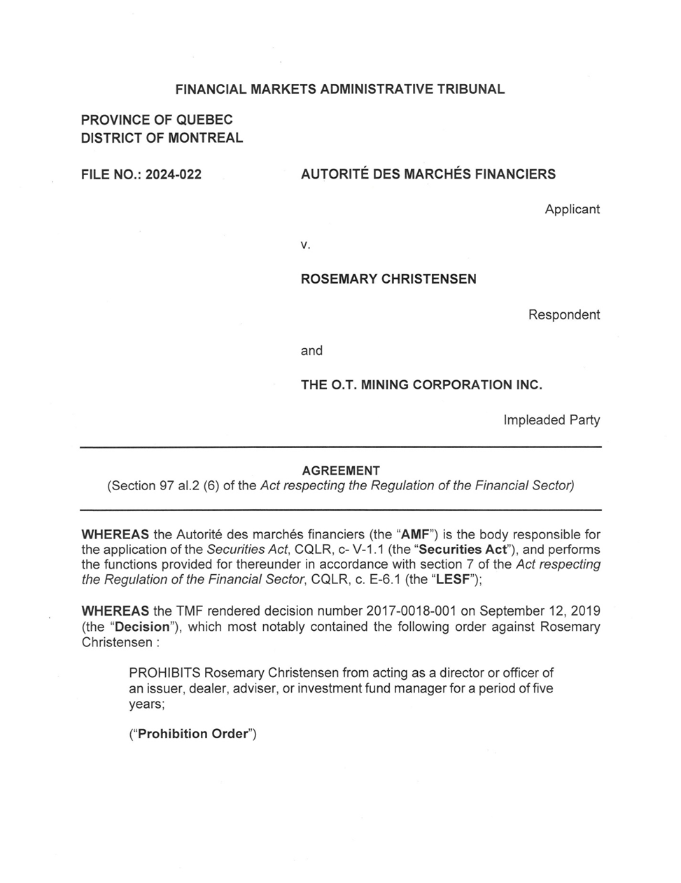

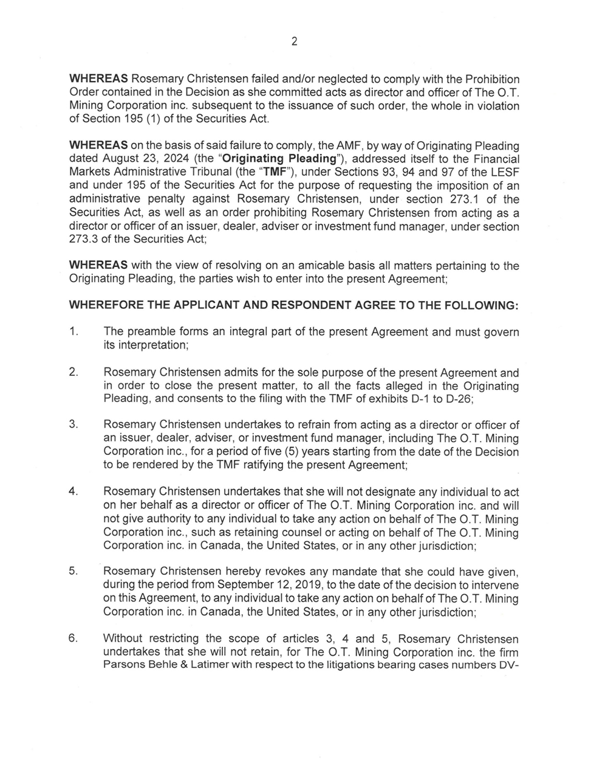

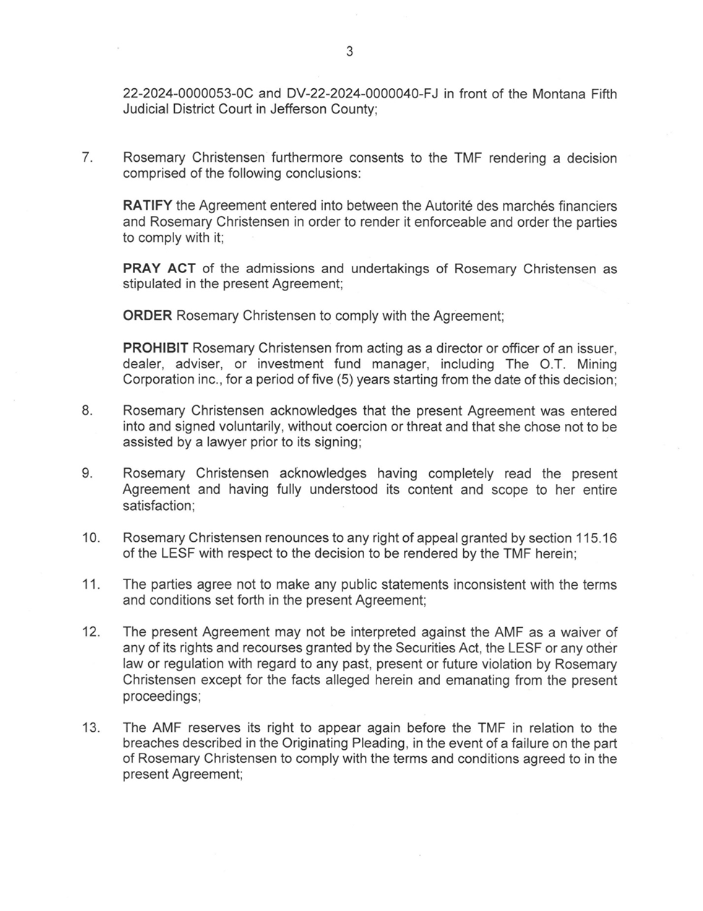

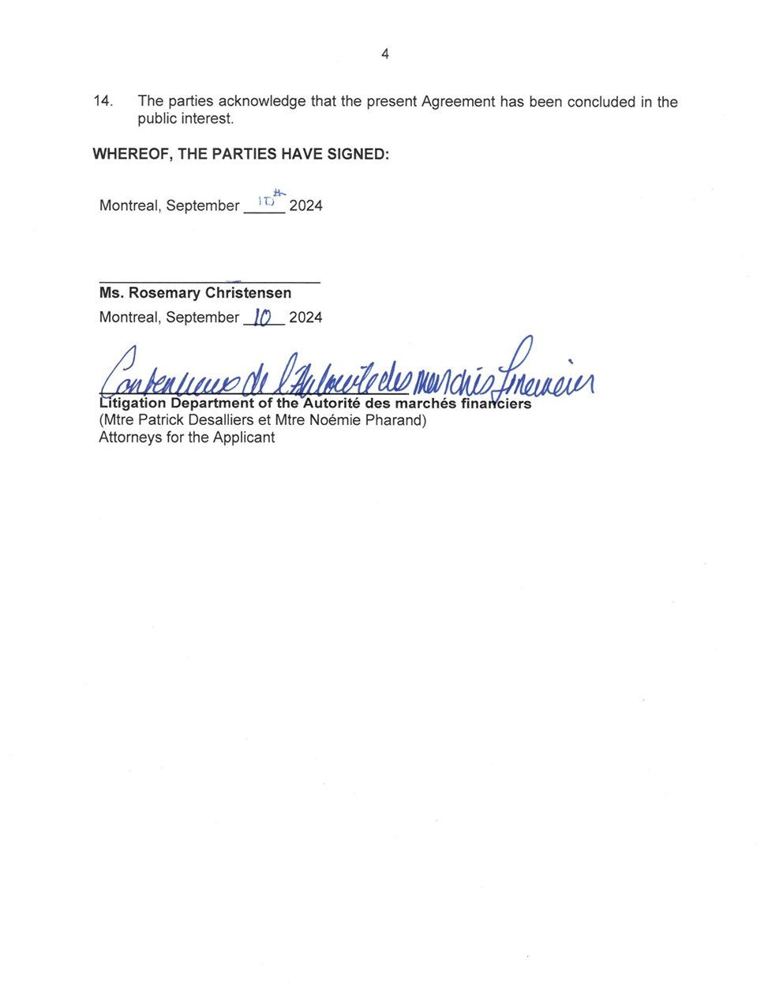

1. *Autorité des marchés financiers* *c.* *O.T. Mining Corporation inc.*, 2019 QCTMF 48, upheld on appeal by *OT Mining Corporation Inc*. *c.* *Autorité des marchés financiers*, 2021 QCCQ 4681.
2. CQLR c V-1.1 [*Securities Act*].
3. A copy of the agreement dated September 10, 2024, is attached to this decision.
4. Section 97, para. 2(6), of the *Act respecting the regulation of the financial sector*, CQLR, c. E-6.1 [*Act respecting the regulation of the financial sector*].
5. For an exhaustive review of the conditions allowing the Tribunal to ratify an agreement, see in particular *Autorité des marchés financiers* c. *Moreau*, 2021 QCTMF 51.
6. *Autorité des marchés financiers* *c*. *9379-4899 Québec inc.*, 2020 QCTMF 43 at para. 29.
7. Section 93 of the *Act respecting the regulation of the financial sector.*
8. See *Autorité des marchés financiers* *c.* *Ben-David*, 2021 QCTMF 63, in which the Tribunal examined the nature and extent of the failure to comply with its decisions.
9. Section 273.3 of the *Securities Act.*
10. Section 94 of the *Act respecting the regulation of the financial sector.*
11. *Committee for the Equal Treatment of Asbestos Minority Shareholders v. Ontario (Securities Commission),* 2001 SCC 37.
12. *Cartaway Resources Corp. (Re)*, 2004 SCC 26.