**Translated from the original French**

|  |  |  |  |
| --- | --- | --- | --- |
| Autorité des marchés financiers c. Grégoire | | | 2024 QCTMF 72 |
| FINANCIAL MARKETS ADMINISTRATIVE TRIBUNAL | | | |
|  | | | |
| CANADA | | | |
| PROVINCE OF QUEBEC | | | |
| MONTREAL | | | |
|  | | | |
| FILE NO.: | 2023-012 | | |
|  | | | |
| DECISION NO.: | 2023-012-002 | | |
|  | | | |
| DATE: | November 8, 2024 | | |
| ______________________________________________________________________ | | | |
|  | | | |
| BEFORE THE ADMINISTRATIVE JUDGES: | | ANTONIETTA MELCHIORRE  CHRISTINE DUBÉ | |
| ______________________________________________________________________ | | | |
|  | | | |
| AUTORITÉ DES MARCHÉS FINANCIERS | | | |
| Applicant | | | |
| v. | | | |
| JOCELYN GRÉGOIRE | | | |
| and | | | |
| **9256-7619 QUÉBEC INC.** | | | |
| and | | | |
| **FRANÇOIS BÉLANGER** | | | |
| Respondents  and  **ATTORNEY GENERAL OF QUEBEC**  Impleaded party | | | |
| ______________________________________________________________________ | | | |
|  | | | |
| DECISION  (Application to ratify an agreement between the Autorité des marchés financiers and François Bélanger) | | | |
| ______________________________________________________________________ | | | |
|  | | | |

# OVERVIEW

1. The Autorité des marchés financiers (the “Authority”) and François Bélanger ask the Tribunal to ratify an agreement reached between them on February 22, 2024 (the “Agreement”).[1]
2. According to the Agreement, François Bélanger essentially acknowledges that he helped the co-respondent Jocelyn Grégoire to distribute a limited partnership’s units to at least 15 investors in contravention of section 11 of the *Securities Act*.[2] François Bélanger also acknowledges having helped Jocelyn Grégoire to act as a dealer in connection with the distribution of these units in contravention of section 148 of the *Securities Act.*
3. The law provides that the Tribunal may “ratify an agreement, if it is in compliance with the law”.[3] The Tribunal must therefore determine whether the Agreement is “in compliance with the law”, allowing it to make the orders suggested by the parties.
4. For the reasons that follow, the Tribunal finds that the Agreement is “in compliance with the law” in that it establishes breaches of the *Securities Act* and the reasonableness of the orders suggested by the parties because they meet the objectives of the protection of the public and of specific and general deterrence.[4]

# ANALYSIS

1. The Tribunal reiterates that it gives significant weight to agreements reached between parties with the aim of putting an end to a dispute.[5] Settling a case helps to improve the accessibility of justice, which is a fundamental principle in a free and democratic society. The law provides that once reached, an agreement is presented to the Tribunal for ratification so long as it is “in compliance with the law”.
2. The criteria establishing whether an agreement is “in compliance with the law” were stated in *Autorité des marchés financiers c. Moreau*.[6] The Tribunal considers that these criteria remain appropriate.
3. Essentially, an agreement is “in compliance with the law” if it allows the Tribunal to (i) establish a breach of the statutes within its jurisdiction or an act contrary to the public interest under the applicable provisions[7] and (ii) determine the reasonableness of the orders suggested by the parties[8] in that they must meet the objectives of the protection of the public and of deterrence.[9]
4. It bears recalling that the Tribunal’s orders are regulatory and, as such, they are neither remedial nor punitive, although they may be deterrent.[10] Indeed, the aim of an order is not to remedy damage caused to investors or financial markets, nor to punish the party that has contravened the law. Rather, the aim is to prevent future wrongdoing that is likely to be prejudicial to the public interest.[11] These orders are protective and preventive.[12]
5. When analyzing whether an agreement is “in compliance with the law”, the Tribunal exercises its discretion in the public interest.[13]
6. The Tribunal may, in the public interest, refuse to ratify an agreement that would be unreasonable or likely to bring the administration of justice into disrepute.[14]
7. Even though the Tribunal must show deference to an agreement reached between the parties, it plays an active role in the process leading to the ratification of an agreement. It is never required to accept the conclusions of an agreement or the joint suggestions proposed by the parties that would not be “in compliance with the law”.

History of the proceedings instituted by the Authority

1. Before analyzing the Agreement, the Tribunal deems it relevant to conduct an overview of the proceedings instituted by the Authority in the context of which the Agreement was reached.
2. In April 2023, the Authority filed an originating pleading (the “Originating Pleading”)[15] with the Tribunal in which it alleges that:

*Jocelyn Grégoire and 9256-7619 Québec inc. (“Cedma Finance”):*

1. Acted respectively as a mortgage broker and a firm offering products and services in the mortgage brokerage sector without being registered with the Authority, in contravention of the *Act respecting the distribution of financial products and services*;[16]
2. Distributed syndicated mortgages, a form of investment to which the *Securities Act* applies,[17] to lenders without preparing a prospectus subject to a receipt issued by the Authority;
3. Acted as a securities dealer or adviser without being registered as such with the Authority with respect to the distribution of syndicated mortgages.

*Jocelyn Grégoire:*

1. Distributed units of the limited partnership Projet PL S.E.C. (“Projet PL”), a form of investment to which the *Securities Act* applies,[18] without preparing a prospectus subject to a receipt issued by the Authority; and
2. Acted as a securities dealer in connection with the distribution of Projet PL’s units without being registered with the Authority.
3. Due to the alleged breaches of the *Act respecting the distribution of financial products and services* and the *Securities Act*, the Authority asks the Tribunal to make orders that aim notably to put an end to the breaches with respect to:

*Jocelyn Grégoire:*

1. Prohibiting him from engaging directly or indirectly in any activity in respect of a securities transaction regarding any form of investment covered by the *Securities Act*, with the exception of transactions made for his own account through a registered dealer and in compliance with the *Securities Act*.
2. Prohibiting him from acting as a director or officer of a firm for a period of five (5) years pursuant to the *Act respecting the distribution of financial products and services*, and from acting as a director or officer of an issuer, dealer, adviser, or investment fund manager for a period of five (5) years pursuant to the *Securities Act*;
3. An administrative penalty of $220,000 for the breaches related to the distribution of units of the limited partnership Projet PL.

*Jocelyn Grégoire and Cedma Finance:*

1. An administrative penalty of $80,000 solidarily for the breaches related to the distribution of syndicated mortgages;
2. An administrative penalty of $200,000, solidarily, for the breaches related to the contraventions of the Tribunal’s decision bearing number 2023-012-001;[19] and
3. An order requiring them to disgorge to the Authority the amount of $82,515 obtained as a result of the contraventions of the Tribunal’s decision.
4. The Authority accuses François Bélanger of (1) having helped Jocelyn Grégoire to distribute Projet PL’s units in contravention of section 11 of the *Securities Act* and, in so doing, (2) having helped Jocelyn Grégoire to act as a securities dealer in contravention of section 148 of the *Securities Act*.
5. Last, the Authority asks the Tribunal to ratify the Agreement and impose an administrative penalty of $23,000 on François Bélanger.

Summary of the Agreement

1. According to the Agreement, François Bélanger acknowledges that he helped Jocelyn Grégoire to distribute Projet PL’s units to at least 15 investors in contravention of section 11 of the *Securities Act*, which states that “[e]very person intending to make a distribution of securities shall prepare a prospectus that shall be subject to a receipt issued by the Authority”.
2. François Bélanger also acknowledges that he helped Jocelyn Grégoire to act as a securities dealer in connection with the distribution of Projet PL’s units in contravention of section 148 of the *Securities Act*, which states that “[n]o person may act as a dealer, adviser or investment fund manager unless the person is registered as such”.
3. Following these admissions, François Bélanger consented to the Tribunal imposing an administrative penalty of $23,000 on him pursuant to section 273.1 of the *Securities Act*, which provides that the Tribunal may impose a penalty on a person who has, by an act or omission, contravened or aided in the contravention of a provision under the *Act* or a regulation made under its authority.

Evidence of a breach of the law or an act contrary to the public interest

1. Essentially, the Tribunal must determine whether the content of the Agreement allows it to conclude that there was a breach and thus make the orders proposed by the parties.[20] The Tribunal need not assess the probative value of the evidence as it does during a hearing on the merits of a case. The Tribunal conducts this analysis by considering the proceedings in the context of which the Agreement was reached, in particular the Originating Pleading, the admissions, the facts alleged in the Agreement, which are taken as true, and the absence of evidence to the contrary. In this regard, the Tribunal recalls that thus far, there is no evidence that allows the Tribunal to refute the facts related by the Authority and François Bélanger in the Agreement.[21]
2. Evidence of a breach of the law may be made in several ways, including by admission.[22] An agreement must include the respondent’s acknowledgment of the facts that are contrary to their interests and likely to result in legal consequences for them.[23]
3. The admissions in an agreement generally constitute judicial admissions that make complete proof against the party admitting them.[24] In addition, [translation] “due to the legal nature of admissions and insofar as admissions respect the conditions of their existence, the facts admitted by the parties will be taken as true”.[25] These facts must not, however, be obviously false or inaccurate.[26] The Tribunal recalls that admissions result in legal consequences for the person who makes them and not for third persons.
4. When analyzing an agreement reached between the parties, the Tribunal considers not only the admissions, but also that the allegations in the agreement that contextualize the situation and support the existence of a breach of the law are, at first glance, true.
5. This determination of the existence of a breach of the law may not be set up against respondents who have not reached an agreement. Their rights are not affected by the Tribunal’s decision ratifying an agreement.[27] An acknowledgment by the party that reached the Agreement (François Bélanger) may not be set up as an admission against the co-respondents who have not reached an agreement with the Authority (Jocelyn Grégoire and Cedma Finance).[28] In addition, the co-respondents who have not reached an agreement with the Authority are not bound by the reasons for the Tribunal’s decision ratifying the Agreement.

Existence of a breach of the law

1. The Tribunal must therefore ratify the Agreement by considering François Bélanger’s admissions and taking the facts alleged in the Agreement as true given the absence of evidence to the contrary.
2. According to the Agreement:[29]

* At the time of the relevant facts, François Bélanger was not registered with the Authority in any capacity;[30]
* Investissements Belabri inc. (a corporation controlled by François Bélanger) and 9405-9276 Québec inc. (a corporation controlled by Jocelyn Grégoire at the time) were not registered with the Authority either;[31]
* Between 2019 and 2020, François Bélanger and Jocelyn Grégoire were business partners in Projet PL, an enterprise that aimed to optimize [translation] “real estate holdings” to make a profit;
* Projet PL never issued a prospectus subject to a receipt of the Authority or had a receipt for a prospectus or an exemption;[32]
* François Bélanger was mainly responsible for the operational administration of the [translation] “real estate holdings” whereas Jocelyn Grégoire was mainly responsible for raising capital and contact with investors. Jocelyn Grégoire was the president and director of Projet PL until December 11, 2020;
* Through the “Mordus d’immobilier” website and Facebook page, Jocelyn Grégoire invited the public to webinars concerning real estate investment via a limited partnership;
* François Bélanger participated with Jocelyn Grégoire in certain presentations concerning Projet PL that aimed to recruit investors;
* In response to the advertisements and presentations, some investors contacted Jocelyn Grégoire, who spoke or met with them to give a more detailed explanation of Projet PL;
* Jocelyn Grégoire and François Bélanger distributed advertising documents to incite investors to subscribe to Projet PL’s units;
* Throughout 2019 and 2020, Projet PL distributed its units to slightly over 50 investors through 9405-9276 Québec inc. and Investissements Belabri inc.

1. At the outset, the Tribunal notes that the raising of capital implies that Projet PL distributed its units within the meaning of the *Securities Act*[33] by seeking investors (either subscribers or acquirers of its securities) by various means (website, social media, webinars, and presentations).[34] In this context, according to François Bélanger’s version, he helped Jocelyn Grégoire act as an intermediary to seek subscribers or acquirers of Projet PL’s units, as he was the point of contact for investors. Therefore, according to François Bélanger’s version, he assisted Jocelyn Grégroire in making a distribution within the meaning of the *Securities Act*.[35]
2. In addition, the steps taken with investors that aimed to further distribution constitute dealer activities within the meaning of the *Securities Act*.[36]
3. With respect to the assistance that François Bélanger provided to Jocelyn Grégoire, the Agreement states that:

* François Bélanger participated with Jocelyn Grégoire in certain presentations concerning Projet PL that aimed to recruit investors;
* François Bélanger occasionally sought to obtain and obtained subscribers for Projet PL’s units;
* François Bélanger distributed advertising documents to incite investors to subscribe to Projet PL’s units;
* François Bélanger participated in the distribution of units of Projet PL by completing the corporate documents allowing Belabri inc. to transfer units of Projet PL to investors.[37]

1. Accordingly, François Bélanger’s admissions, the facts alleged in the Agreement, which the Tribunal takes as true, and the absence of evidence to the contrary allow the Tribunal to make the orders proposed by the parties, the whole for having helping Jocelyn Grégoire to (1) distribute units of Projet PL to at least 15 investors in contravention of section 11 of the *Securities Act* and (2) act as a dealer in connection with the distribution of Projet PL’s units in contravention of section 148 of the *Securities Act*.

Reasonableness of the administrative penalty suggested by the parties

1. In its analysis, the Tribunal considers the teachings of *Demers*[38] with respect to the applicable criteria for assessing the orders it makes in response to a breach of the law. The analysis in that decision is repeated in numerous decisions of the Tribunal and defines a framework that takes into account the factors to consider when imposing administrative measures to protect the public, according to the circumstances of each case.[39]
2. The Tribunal also considers certain mitigating factors that were stated during the hearing, including François Bélanger’s admissions, which are detailed in the Agreement, and his cooperation with the Authority after the Originating Pleading was filed. In addition, the Tribunal considers the fact that François Bélanger wants to make amends as, according to the agreement, he plans to buy back Projet PL’s units still held by investors. Last, it was stated at the hearing that François Bélanger is now apparently registered as a dealer, or in the process of registering as such, which demonstrates his willingness to comply with the law.
3. In light of the Agreement and following the parties’ arguments, the Tribunal finds that the orders suggested by the parties are reasonable in that they allow the objectives of the protection of the public and of specific and general deterrence to be met.
4. In view of the foregoing, the Agreement is “in compliance with the law”, thus allowing the Tribunal to make the orders suggested by the parties.

**FOR THESE REASONS**, pursuant to sections 93, 94, and 97 (subparagraph (6) of the second paragraph) of the *Act respecting the regulation of the financial sector* and section 273.1 of the *Securities Act*, the Financial Markets Administrative Tribunal:

**RATIFIES** the agreement between the Autorité des marchés financiers and François Bélanger, takes note of the undertakings therein, makes it enforceable, and orders the parties to comply therewith;

**IMPOSES** on François Bélanger an administrative penalty of $23,000 payable to the Autorité des marchés financiers according to the terms set out in the Agreement;

**AUTHORIZES** the Autorité des marchés financiers to collect payment of the administrative penalty imposed.

|  |  |  |  |
| --- | --- | --- | --- |
|  | | | |
|  | | __________________________________  **Antonietta Melchiorre**  **Administrative Judge**  __________________________________  **Christine Dubé**  **Administrative Judge** | |
| Mtre Jean-Benoît Hébert  Mtre Éloïse Duplessis  Gabrielle Genest, articling student | | |
| (Litigation Services, Autorité des marchés financiers) | | |
| For the Autorité des marchés financiers  Mtre Daniel Baum  Laurianne Duquette, articling student  (Langlois Lawyers LLP)  For François Bélanger | | |
|  | | |
| Mtre Sabia Chicoine | | |
| (FCA Legal LLP) | | |
| For Jocelyn Grégoire and 9256-7619 Québec inc. | | |
|  | | |
|  | | |
|  | | |
|  | | |
| Date of hearing: | October 31, 2024 | |

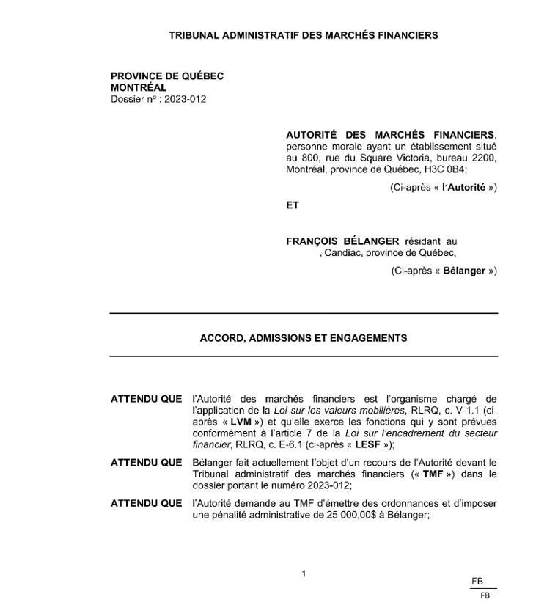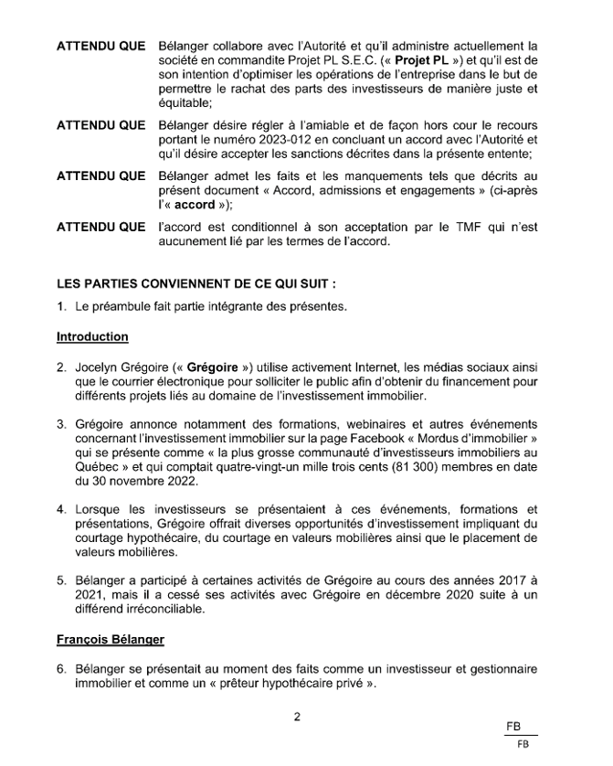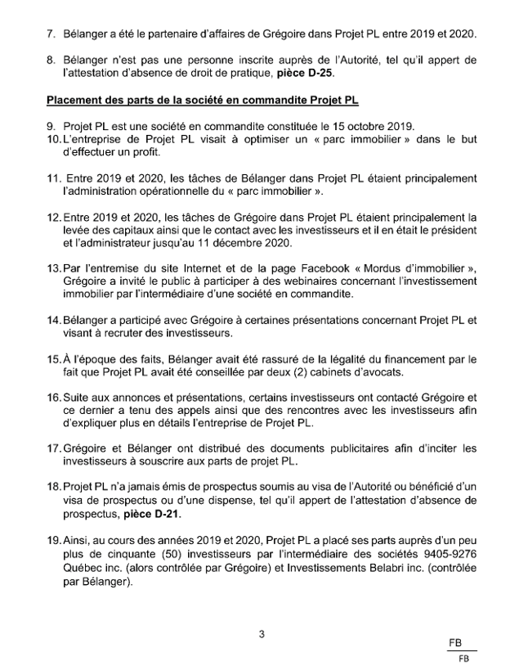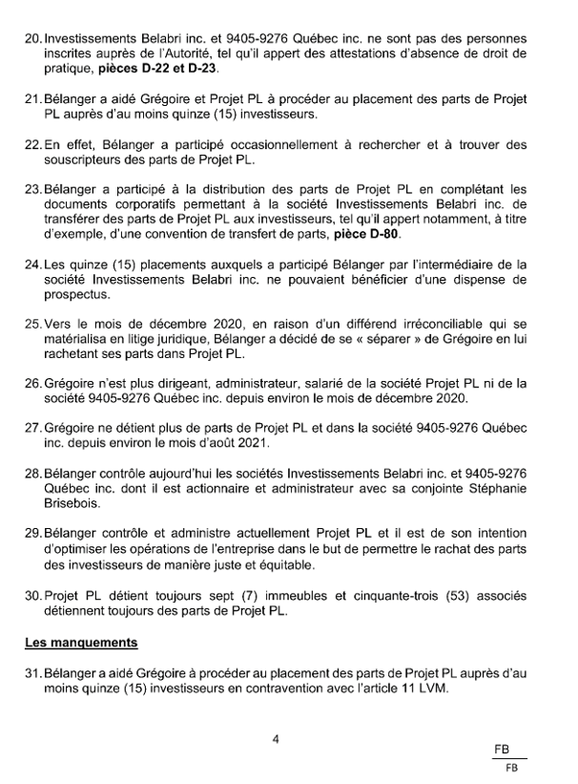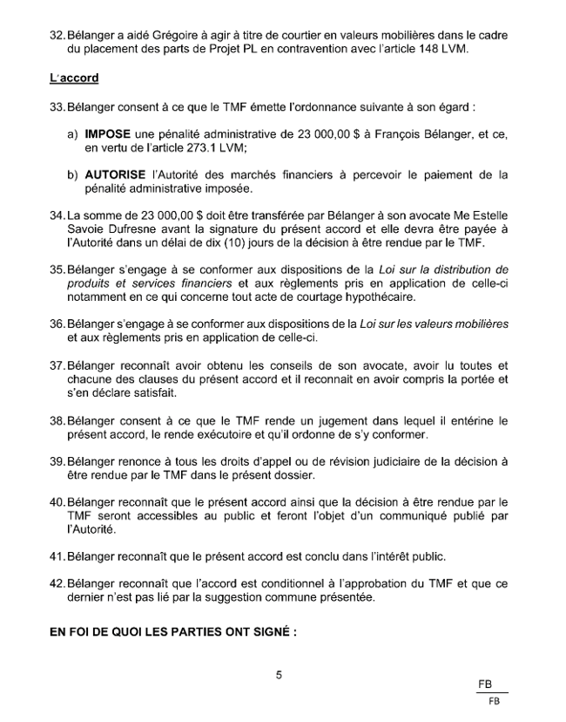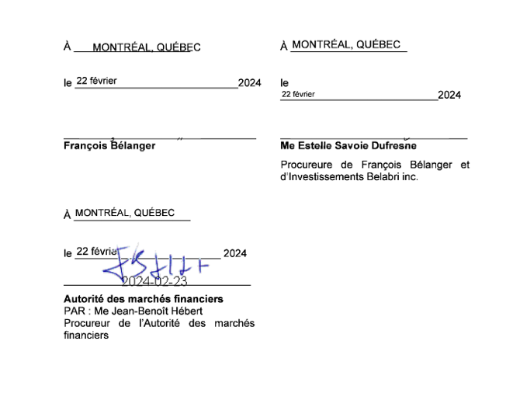

1. A copy of the agreement reached between the parties on February 22, 2024, is attached to this decision.
2. *Securities Act*, CQLR, c. V -1.1.
3. Subparagraph (6) of the second para. of s. 97 of the *Act respecting the regulation of the financial sector*, CQLR, c. E-6.1.
4. *Committee for the Equal Treatment of Asbestos Minority Shareholders v. Ontario (Securities Commission)*, 2001 SCC 37; *Pezim v.* *British Columbia (Superintendent of Brokers)*, [1994] 2 S.C.R. 557; *Cartaway Resources Corp. (Re)*, [2004] 1 S.C.R. 672.
5. *Autorité des marchés financiers c. Moreau*, 2021 QCTMF 51 at para. 28; *Autorité des marchés financiers c. Unissa Assurances inc.*, 2019 QCTMF 42 at para. 85; *Autorité des marchés financiers c. Agence Unie 2000 inc. / United Agency 2000 Inc.*, 2024 QCTMF 65 at para. 15; *Autorité des marchés financiers c. ROI Land Investments Ltd.*, 2024 QCTMF 37 at para. 13; *Autorité des marchés financiers c. TWMG inc.*, 2024 QCTMF 29 at para. 9; *Autorité des marchés financiers c. Cloutier*, 2024 QCTMF 5 at para. 9.
6. *Autorité des marchés financiers c. Moreau*, 2021 QCTMF 51 at paras. 36−38.
7. *Committee for the Equal Treatment of Asbestos Minority Shareholders v. Ontario (Securities Commission)*, 2001 SCC 37; *Re Canadian Tire Corp.*, (1987) Vol. XVIII, no. 14, BCVMQ, A1, 1987 LNONOSC 47, aff’d 1987 CanLII 4234 (ON SC).
8. *Autorité des marchés financiers c. Demers*, 2006 QCBDRVM 17; *Autorité des marchés financiers c. Moreau*, 2021 QCTMF 51 at para. 37.
9. *Autorité des marchés financiers c. Moreau,* 2021 QCTMF 51; *Committee for the Equal Treatment of Asbestos Minority Shareholders v. Ontario (Securities Commission)*, 2001 SCC 37; *Pezim v.* *British Columbia (Superintendent of Brokers)*, [1994] 2 S.C.R. 557; *Cartaway Resources Corp. (Re)*, [2004] 1 S.C.R. 672.
10. *Committee for the Equal Treatment of Asbestos Minority Shareholders v. Ontario (Securities Commission)*, 2001 SCC 37; *Pezim v.* *British Columbia (Superintendent of Brokers)*, [1994] 2 S.C.R. 557; *Cartaway Resources Corp. (Re)*, [2004] 1 S.C.R. 672.
11. *Committee for the Equal Treatment of Asbestos Minority Shareholders v. Ontario (Securities Commission)*, 2001 SCC 37.
12. *Committee for the Equal Treatment of Asbestos Minority Shareholders v. Ontario (Securities Commission)*, 2001 SCC 37.
13. *Act respecting the regulation of the financial sector*, s. 93. The expression “public interest” includes the protection of investors, the efficiency of capital markets, and the preservation of public confidence in the protection of investors and the efficiency of markets: *Committee for the Equal Treatment of Asbestos Minority Shareholders v. Ontario (Securities Commission)*, 2001 SCC 37; *Pezim v.* *British Columbia (Superintendent of Brokers)*, [1994] 2 S.C.R. 557; *Pacific* *Coast Coin Exchange of Canada Ltd. (Re) v. Ontario Securities Commission*, [1978] 2 S.C.R. 112.
14. *Autorité des marchés financiers c. Moreau*, 2021 QCTMF 51 at para. 32.
15. The Originating Pleading was subsequently amended, and the last amendment is dated October 1, 2024.
16. Sections 12, 14, 15, 71, and 461 of the *Act respecting the distribution of financial products and services*, CQLR, c. D-9.2.
17. Sections 1 and 2.36 of *Regulation 45-106 respecting Prospectus Exemptions*, c. V-1.1, r. 21.
18. Section 1.7 of the *Securities Regulation*, c. V-1.1, r. 50, provides that a limited partnership’s unit is a form of investment to which the Securities Act applies.
19. *Autorité des marchés financiers c. Grégoire*, 2023 QCTMF 85.
20. *Eurovia Québec Construction inc. c. Couture Rouillard*, 2024 QCTAT 3341; *Commission des normes, de l’équité, de la santé et de la sécurité du travail c. Tribunal administratif du travail*, 2016 QCCS 3814 at paras. 23–25.
21. Jocelyn Grégoire and Cedma Finance will have the opportunity to present such evidence, if any, at the hearing on the merits of the case.
22. *Autorité des marchés financiers c. Moreau*, 2021 QCTMF 51 at para. 40. Under art. 2811 of the *Civil Code of Québec*, an admission is a means of proof equivalent to a writing, testimony, presumption, or the production of real evidence.
23. *Autorité des marchés financiers c. Moreau*, 2021 QCTMF 51 at para. 41; *Autorité des marchés financiers* c. *Unissa Assurances inc*., 2019 QCTMF 42; art. 2850 CCQ.
24. *Autorité des marchés financiers c. Moreau*, 2021 QCTMF 51 at para. 41 and art. 2852 CCQ.
25. *Autorité des marchés financiers c. Moreau*, 2021 QCTMF 51 at para. 44.
26. *Autorité des marchés financiers c. Moreau*, 2021 QCTMF 51 at para. 49; *Autorité des marchés financiers c. Unissa Assurances inc.*, 2019 QCTMF 42 at para. 115; *Commission des normes, de l’équité, de la santé et de sécurité du travail (CNESST) c. Tribunal administratif du travail*, 2016 QCCS 3814 at paras. 23–25.
27. *Gollogly v. Ontario Securities Commission*, 2007 CanLII 57936 (ON SCDC).
28. *Compagnie d’assurance continentale du Canada c. Compagnie d’assurance générale dominion du Canada*, 1996 CanLII 6449 (QC CA) at 4.
29. More specifically, paras. 6−30 of the Agreement.
30. Exhibit D-25.
31. Exhibits D-22 and D-23.
32. Exhibit D-21.
33. Subparagraph 1 of the definition of distribution set out in s. 5 of the *Securities Act*.
34. Subparagraph 1 of the definition of distribution set out in s. 5 of the *Securities Act*.
35. Subparagraph 7 of the definition of distribution set out in s. 5 of the *Securities Act*.
36. Subparagraph 3 of the definition of dealer set out in s. 5 of the *Securities Act*.
37. For example, see exhibit D-80.
38. *Autorité des marchés financiers c. Demers*, 2006 QCBDRVM 17.
39. *Autorité des marchés financiers c. Demers*, 2006 QCBDRVM 17.